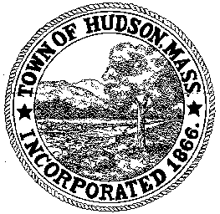

CONSERVATION COMMISSION
78 Main Street, Hudson, MA 01749
(978) 562-2020

Leif Longtine, Chairman David Esteves, Vice Chairman Paul Byrne, Member

David Mercer, Member Joseph Rodrigues, Member Al Tashian, Member W. Minot Wood, Member

Meeting Agenda
August 1, 2013
7:00 P.M.

- Preliminaries
  - Open Meeting
  - Roll Call

2.0 New Business
2.1 RDA 450
Applicant: Kieu Dao
Location: 151 Forest Avenue
Project Description: Removal of several trees

2.2 RDA 452
Applicant: Lewis and Carol Collins
Location: 3 John Robinson
Project Description: removal of several dead trees and potentially removing Norway Maples in the future.

2.3 Enforcement Order
281 Washington Street

2.4 RDA 453
Applicant: One Cabot Road Hudson, LLC
Location: 280 Washington Street
Project Description: pavement of a 14’ emergency gated access drive

2.5 DEP 190-0573
Applicant: Joseph Lynch, One Cabot Road Hudson LLC
Project Description: construction of three apartment buildings with associated site improvements such as an office and club facility, parking and pedestrian access, landscaping, storm water mitigation and underground utilities.

2.6 Minutes – July 18, 2013

2.7 Voucher – CC080113 $17.50

3.0 Old Business
4.0 Correspondence
5.0 Adjournment

Next Meeting is August 15, 2013

